**SOFTWARE DEVELOPMENT LABORATORY**

**EXPIMENT 4:**

**VIEW YOUR WORK**

**AIM:**

To view the progress of the work team members are going through.  By reporting on and tracking their work, team members ensure that the correct information about the remaining work in a sprint is presented.  Given that the scrum method emphasizes completed work, not started work, start and complete a work item before you move to the next item.

**PROCEDURE:**

In the Monday.com website sign up with email and password and create the project with the necessary details.

Open the release backlog by opening the respective project name.

View your workload in the task board: on the Workspace tab, in the Dataset iteration.

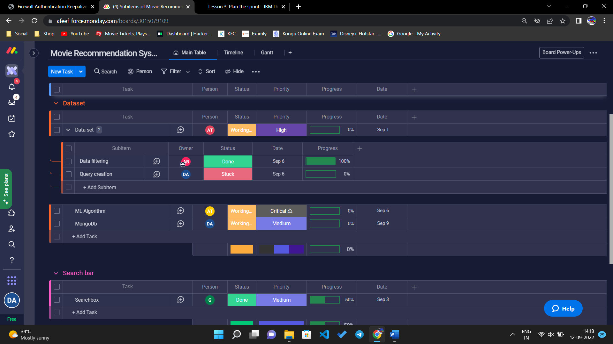

View sprint to make sure the task is on process and needs attention to get that done. Update the work progress of the particular task every time the things get done.

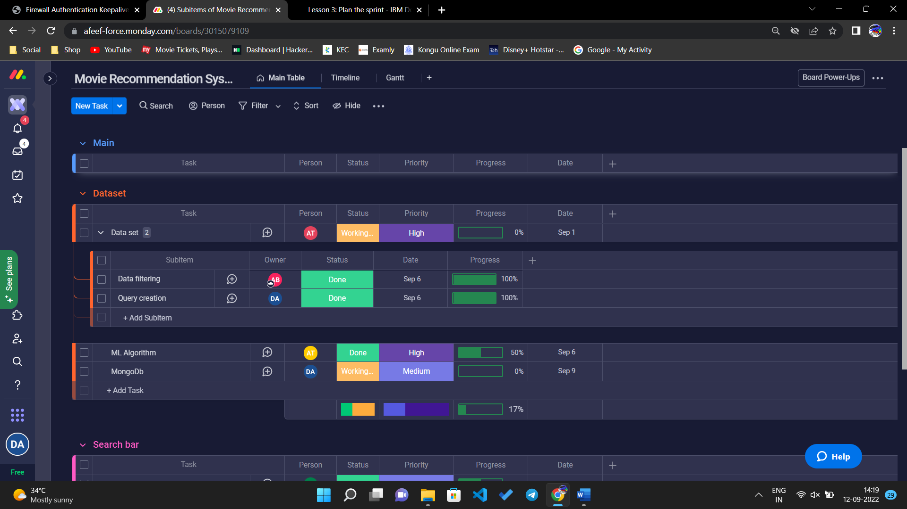

The task assigned for each team members can be viewed by selecting particular person in the taskbar.

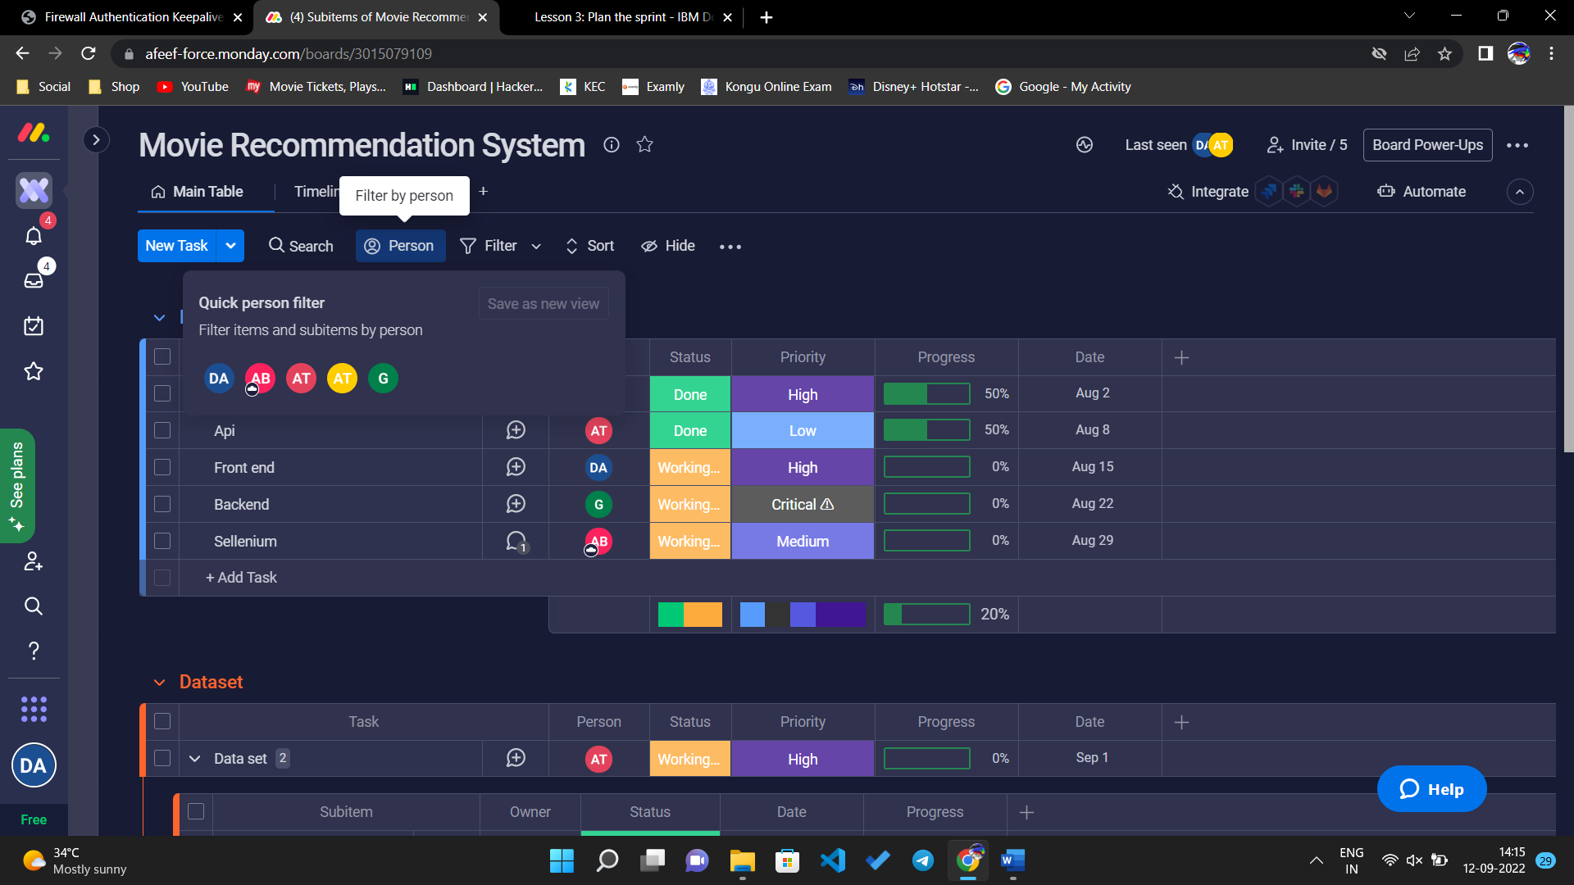

Click the tab person and select the particular person whom work progress need to be known.

The work of that particular person can be viewed.

Each team members progress can be check by this.



**CONCLUSION:**

Any team member can update information in the discussion section, which provides an excellent way to capture the history of the work item and use a collaborative approach.